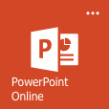Power Point Assignment checklist
Welcome to your First personal assignment for PowerPoint. This assignment will cover the basics. For this assignment, you need to complete the following checklist.

Topic of PPT: Your favourite star

2 animations on 1 slide.
Write your favorite star’s (Anime character is fine) name in a WordArt
Have a picture of your star on slide 3
2 slides where the words comes first then the picture.
1 slide where the picture comes first then the words.
There should be NO fuzzy/blurry/low resolution images.
1 slide with a different background.
Maximum 10 slides

Optional topic: Your favourite class

